Principles of Software Engineering Spring 2023

FAU Social Board

Group: SP23G20

Caleb Panoch (Team Lead)

Collin Hammock

Deon Rennie

Colin Hrzich

Luciano Scarpaci

Milestone 1

Date: 3/03/23

Revision History:

|  |  |
| --- | --- |
| 03/02/23 | Document created, added executive summary. |
| 03/03/23 | Finished Milestone 1. All the requirements were added for submission. |
|  |  |
|  |  |
|  |  |

EXECUTIVE SUMMARY

FAU Social board is a website that will allow FAU students to connect on an online platform. This website will allow students to upload photos, comments, or short stories about anything FAU related. The website will have different sections for different themes, such as homework, exercise, food, and more.

COMPETITIVE ANALYSIS

|  |  |  |
| --- | --- | --- |
| Company name: | Their Key Features: | Our Planned Features: |
| Imgur | Images: users upload images to the platform.  Gallery: a collection of the most seen photos on the platform.  Meme generator: allows users to create custom images.  Statistics:  Alexa rank: (96)  Users: 1 billion  Content: 60 Billion images | Users will be able to upload photos to the website in the main feed. |
| Giphy | Online database: this database contains images in the ‘.gif’ file format. It allows the users to search for images.  Statistics:  Alexa rank: (2269)  Users: 700 million  Content: 10 billion images | Each user will have access to the feed and be able to like or dislike a post. |

An advantage of our app versus the competition is that this project will be used specifically for FAU students as opposed to other types of software that are not exclusive to FAU students

DATA DEFINITION

|  |  |  |  |
| --- | --- | --- | --- |
| Name | Meaning | Usage | Comment |
| Account | data | Use case scenarios | Store user information |
| FAU | data | Activity Type | Users are allowed to upload FAU related activity |
| Comments | service | Site user service | Allows the users to leave comments |
| Photos | service | Site user service | Allows visitors or local to upload images |
| Log in | service | Site user service | Allow user the ability to comment, photos and Social Board activities |
| Social Board | service | Site user service | Allows users to upload their favorite activities |
| Web Site | User Interface | User Interface | Front end display for user interaction |
| Home page | User Interface | User Interface | The first page the user is visiting on the website |
| Navigation Tabs | data | Site user service | Allows the user to navigate the website to go to their desired results |
| User | actor | Use case scenarios | General definition of a site visitor or registered user |
| Information Page | User interface | User interface | Page that is displayed when user activity is clicked. The page shows photos, comments, etc. |
| System | Platform hardware and services | Use case scenarios | The MYSQL database, all the code, front end design and back-end services |
| Lamp.eng.fau.edu | server | Use case scenarios | It’s the server that has all of our data |

OVERVIEW, SCENARIOS, AND USE CASES

An FAU student navigates through the tabs to see a feed of photos and messages relevant to that tab. At the top of the page, the user will be able to sort through the feed with different options provided. The user can scroll down through the feed, and they can like or dislike any post. At the bottom of the page, there is an option for the student to upload their own post. It will ask for a username and the contents of the post.

**INITIAL LIST OF HIGH-LEVEL FUNCTIONAL REQUIREMENTS

LIST OF NON-FUNCTIONAL REQUIREMENTS

1. Accesibility: This website will be optimized for desktop usage only. Mobile website requires advanced CSS/SASS skills and is out of scope for the project.
2. Security requirements: Our app will have basic security against XSS attack by setting the Content Security Policy.
3. Storage: This app storage is big enough for the FAU lamp server.
4. Availability: The website will run at 100% UP on FAU’s server and the source code will be hosted on a Git repository on GitHub.
5. Usability: The User can easily navigate the site and experience a styled UI.
6. Fault Tolerence:Error checking by using boolean functions to evaluate successful or failed responses.

HIGH-LEVEL SYSTEM ARCHITECTURE

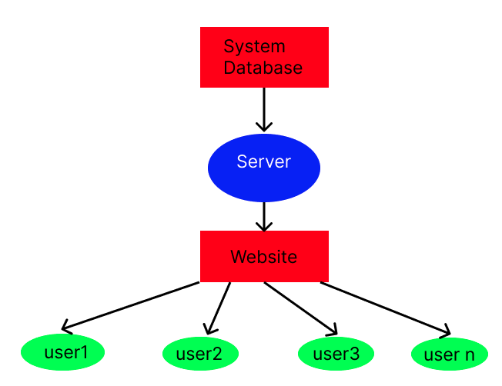

1. Browser Compatibility: This system will be a web-based app that operates well on the latest versions of Mozilla Firefox, and Google Chrome.
2. Subversion: The subversion control system we are using is GitHub.
3. Database: The database for this project is MYSQL database.
4. Microsoft Visual Studio Code: Microsoft Visual Studio Code is the IDE that the developers will be using to code the website and deploy it.

A) Hyper Text Mark-up Language (HTML) - will be the language that will allow the browser to display the website.

B) Cascading Style Sheets (CSS) - will be the language to style the website.

C) Bootstrap (JS) - will be the framework that will be used for stylizing the website and giving its Fonts and UI.

D) Javascript (JS) - will be the language used for client-side functions for the end user in the User Interface.

5) Canvas: Desktop and Mobile Application used by the student to communicate with each other, download required materials, and submit assignments.

6) FAU Lamp Server: Lamp Server given to us by the professor for hosting. The server will be used as a source for our group project.

7) JIRA: Our project board and working status tool. This is our method of tracking code sprints and project progress through the course.

TEAM 20 Roles:

Team Leader: Caleb Panoch

Scrum Master: Colin Hrzich

Developers: Deon Rennie, Luciano Scarpaci, Collin Hammock ([chammock2019@fau.edu](mailto:chammock2019@fau.edu))